## horizontal line



M6: Case Study

**─**

# Our Roles:

Followed the complete Design Thinking process, from problem identification and user research to ideation, prototyping, user testing, and iterative refinement to develop a comprehensive high-fidelity prototype.

# Problem description

With grocery prices rising by **8.5% annually** (source: market data), many individuals struggle to maintain budgets. Rising grocery prices due to inflation are making it difficult for people to stay within budget while maintaining a nutritious diet. Many people struggle to track price trends, compare costs across stores, and make informed purchasing decisions. Without reliable and easy to use tools, people often overspend, face financial strain, or compromise on essential groceries.

**PriceGuard** aims to solve this issue by using technology to provide real-time grocery price tracking, budget-friendly recommendations, and smart spending insights. It promotes responsible consumption **(UN SDG 12)** and helps mitigate the impact of inflation which makes it contribute to food security and affordability **(UN SDG 2)**.

# System goals

PriceGuard provides users with *credible* information which enables them to track accurate prices of grocery items efficiently and quickly. It promotes **responsible consumption (UN SDG 12)** and helps mitigate the impact of inflation which makes it contribute to **food security and affordability (UN SDG 2)**.

## Features

### *Real-Time Price Tracking* – tracks prices at the spot of purchase and compare prices among different stores.

* *Inflation Trend Analysis* – provides the entire trend including the history to have a better understanding of how the inflation has impacted the prices.
* *Personalized Shopping Recommendations* – recognize user’s shopping patterns and provide budget-friendly tips for better financial decision making.
* *Predictive Price Insights* – the app also provides users with information regarding the potential increase on grocery items in the near future.
* *Instantaneous Alerts* – if there is a change in the price of an item, the user is instantly notified to avoid any overspending on an item.

PriceGuard is better than plenty of already available solutions because it is an all-in-one application that will be especially built for middle-aged people who find it difficult to understand trends, PriceGuard will assist them to make better decisions. It provides tracking, comparison, prediction and alerts all in one platform for ease of the users. It also provides personalized shopping assistance.

# HIGH-LEVEL goals

Our goal for this study is to understand how users can track grocery prices, manage their budgets, and make financial decisions for effective purchase in order to reduce the impact of inflation.

Questions:

* *How do grocery shoppers currently track prices and manage budget for groceries?*
* *What problems do grocery shoppers face when tracking price changes?*
* *What features would help grocery shoppers make smarter and cost-effective grocery choices?*
* *Why do grocery shoppers track prices the way they do?*

# Target Audience

The target audience for **PriceGuard** are:

* Low budget households.
* Middle-aged people responsible for grocery shopping and management.
* Students who have limited finance and are living independently.
* Sustainable & Ethical Shoppers interested in responsible consumption who want to avoid waste and make informed purchases.

# Challenges and Constraints

The app:

* Must work for users with minimal tech skills (no complex setups).
* Must adapt to unreliable local data (like missing items or messy receipts), pushing for simple, offline-capable tools over advanced dashboards.
* Retailer APIs are fragmented, and hyper-local price volatility (like Rs. 200 noodle price gaps between stores) demands live data we can't yet scrape reliably.
* Users may have **limited digital literacy** or prefer traditional methods; interface must be highly intuitive
* Physical access to multiple stores is not always feasible, especially with rising fuel costs and time limitations.

# Research Conducted

## Overview of key insights from Interview

The interviews revealed that grocery shoppers, particularly those responsible for household budgeting face significant challenges due to constantly fluctuating prices and lack of reliable price taking tools. Participants emphasized the difficulty of staying within budget, the unpredictability of costs and the effort required to compare prices across stores.

1. Concern of price fluctuation.
2. Participants relied on manual methods such as register and pen, receipts or excel sheets to keep track of their expenses. This tends to be frustrating, arduous and time-taking.
3. Interviewees expressed interest in an app that provides budget tracking and real time price alerts and comparison.
4. We also learned how users seem interested in deals and discounts but are unaware of them due to their specific store’s lacking or are uninformed of offers of other stores.
5. Some interviewees seemed to be interested in foreign products and desired to track inflation effects on such products.
6. Hard to track spending over time.
7. Lack of price tags in stores sometimes leads to budget overruns.

#### **Identified user needs**

1. Price Comparison and Tracking.
2. Predictive Price Trends.
3. Budgeting Assistance.
4. Store Specific deals/discounts and alerts.
5. Predict Fluctuations on Imported Products.
6. Budget dashboards with warnings before overspending.
7. Receipt scanning to auto-categorize spending.
8. Updates on item availability.
9. A **centralized digital solution**

#### **Current practices and challenges**

1. Check online listings.
2. Relying on word of mouth through asking family friends. Participant B mentioned a whatsapp group chat where her friends post recent discounts and price updates.
3. Tracking prices through manual means, often through a register and pen, or excel sheet. Participants expressed great frustration in how time-consuming and arduous this task can be. According to Participant A, “I end up dreading this task the most”.
4. Some interviewees have started to avoid imported items due to increased priced from inflation.
5. Interviewees also observed increase in necessity-driven consumption and a decrease in wants-based spending,
6. Unexpected price hikes and missing tags disrupt budgets, forcing last-minute trade-offs without centralized tracking.
7. Saves receipt photos to track spending but wants a scanner tool to automate budgeting and price comparisons without extra effort.
8. Manual comparison between stores is time-consuming and sometimes limited by transportation or store access.
9. Shopping decisions are often made using habit, intuition, or prior experience rather than real-time data.
10. Users often experience **budget overshoots**, especially when unexpected price spikes occur at the time of shopping.

## 1.5 research methods & evidence

#### **Initial Affinity Wall:**

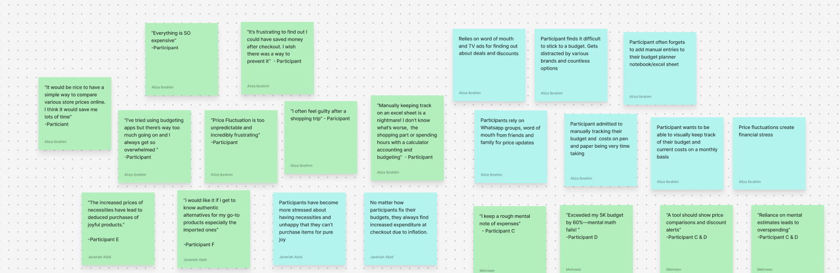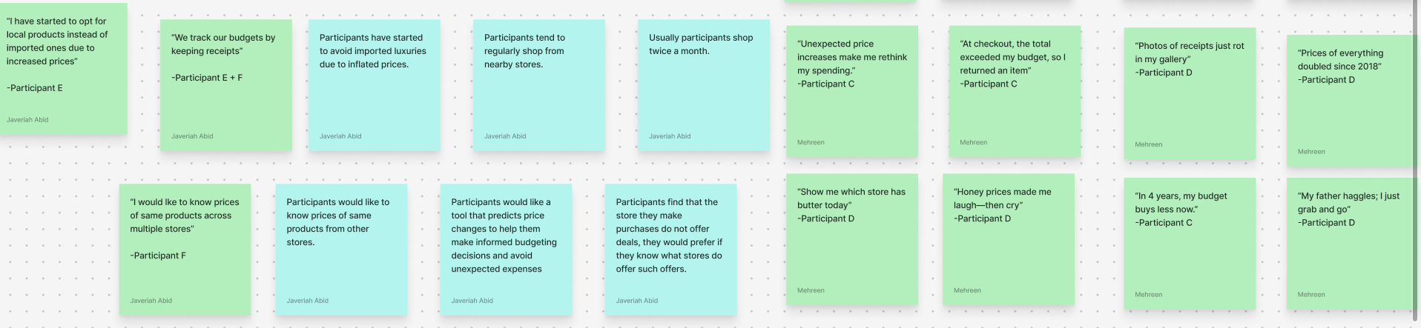

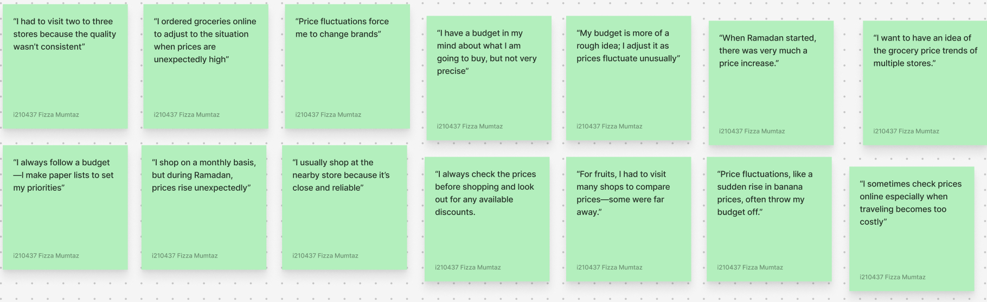

#### 

#### **Final Affinity Wall:**

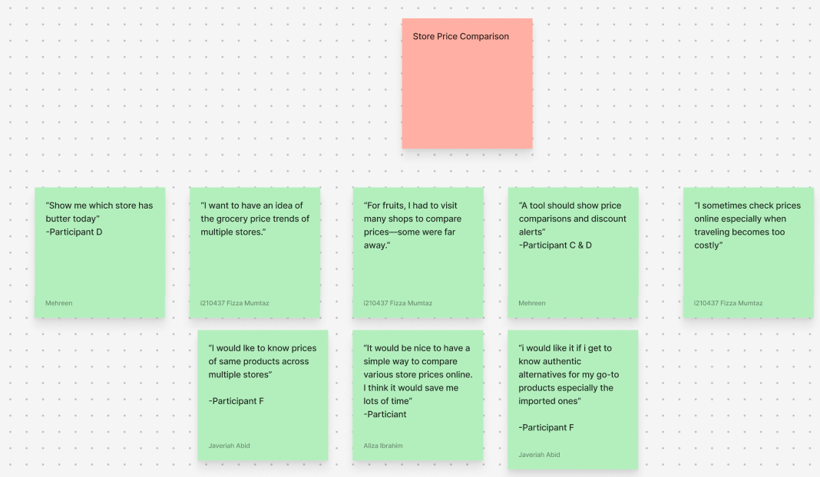

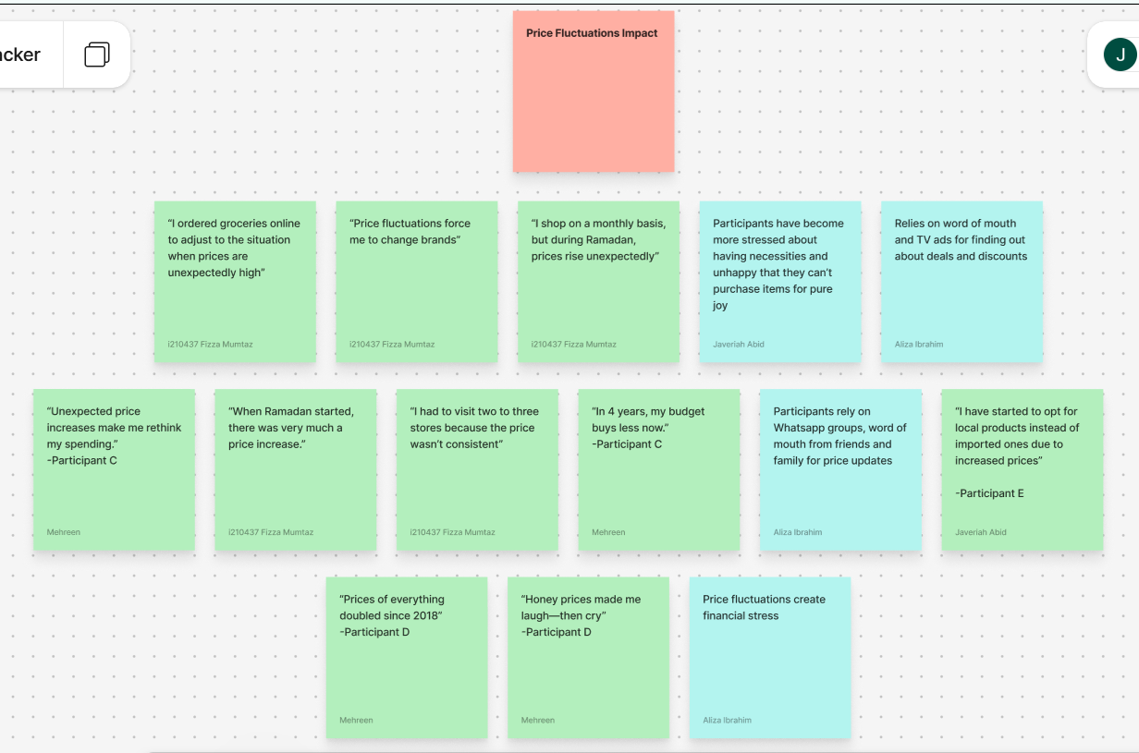

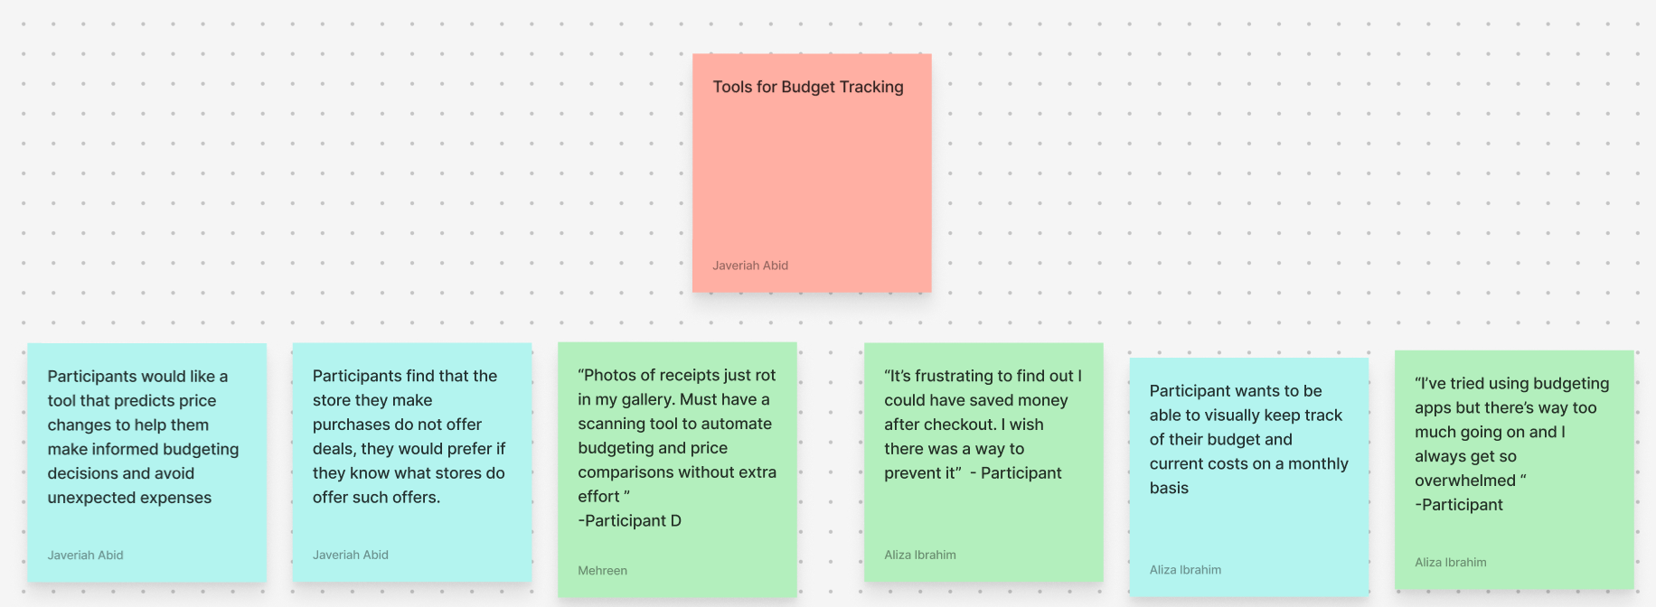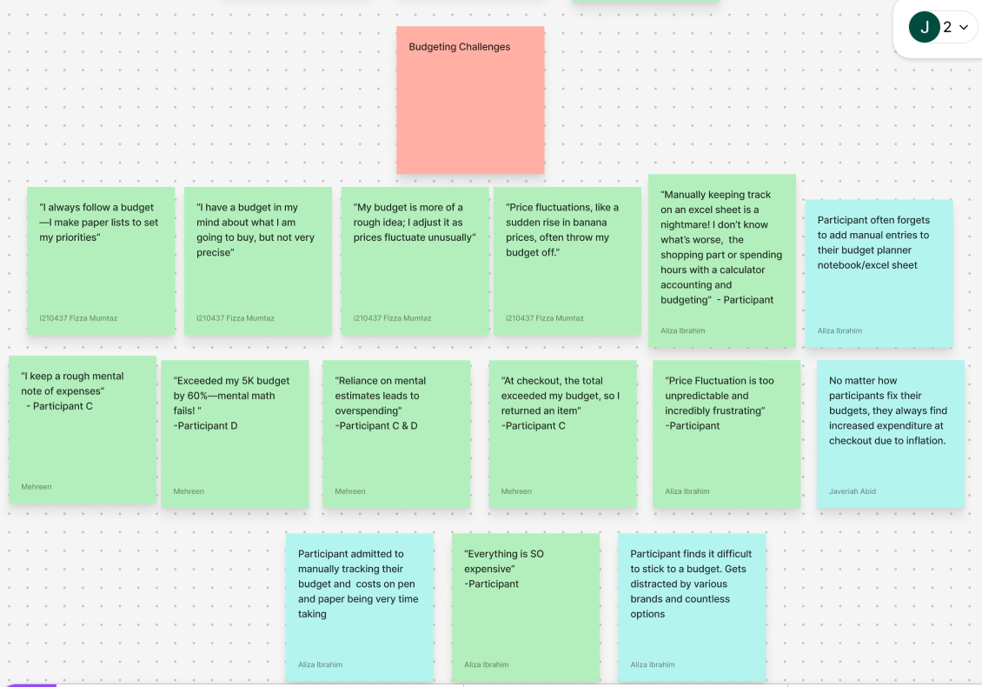

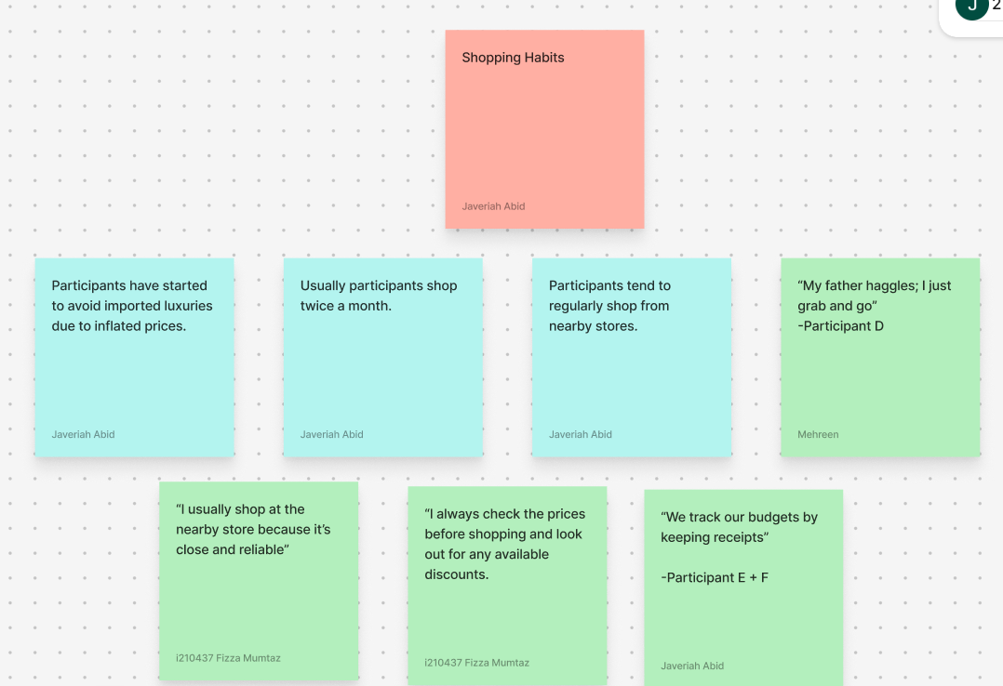

# Empathy maps

#### **Participant A**

#### 

#### 

#### 

#### 

#### 

#### **Participant B**

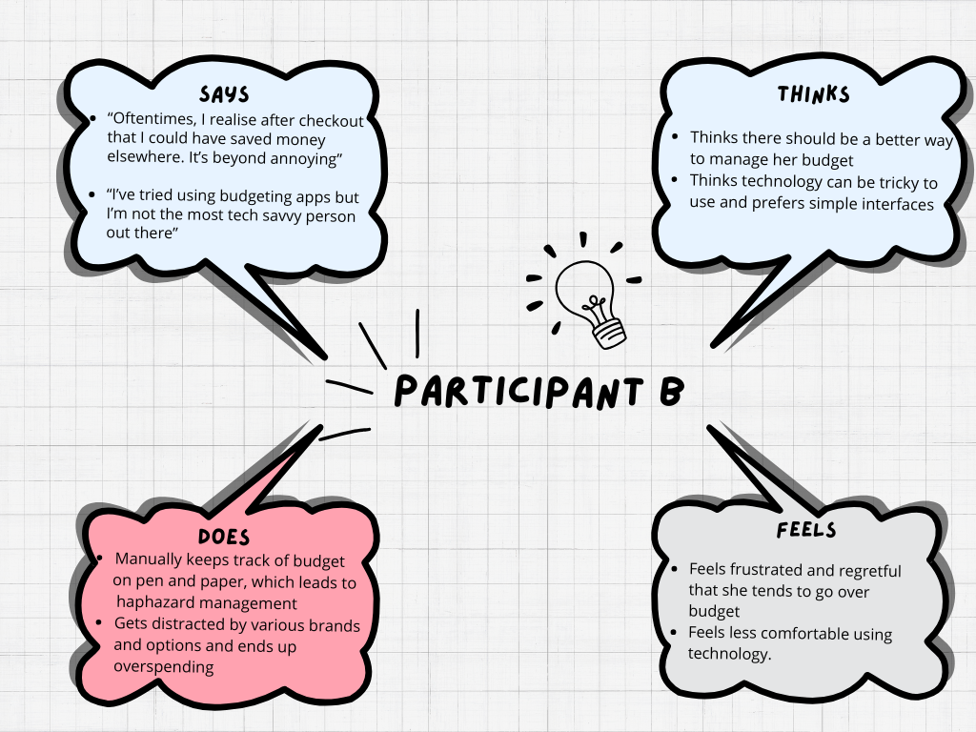

#### **Participant C**

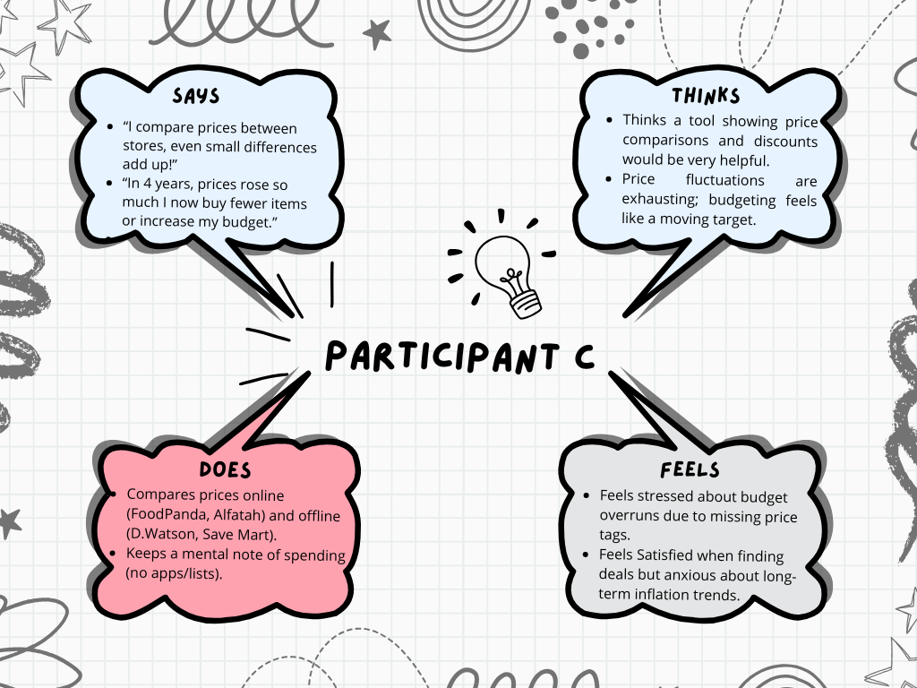

#### **Participant D**

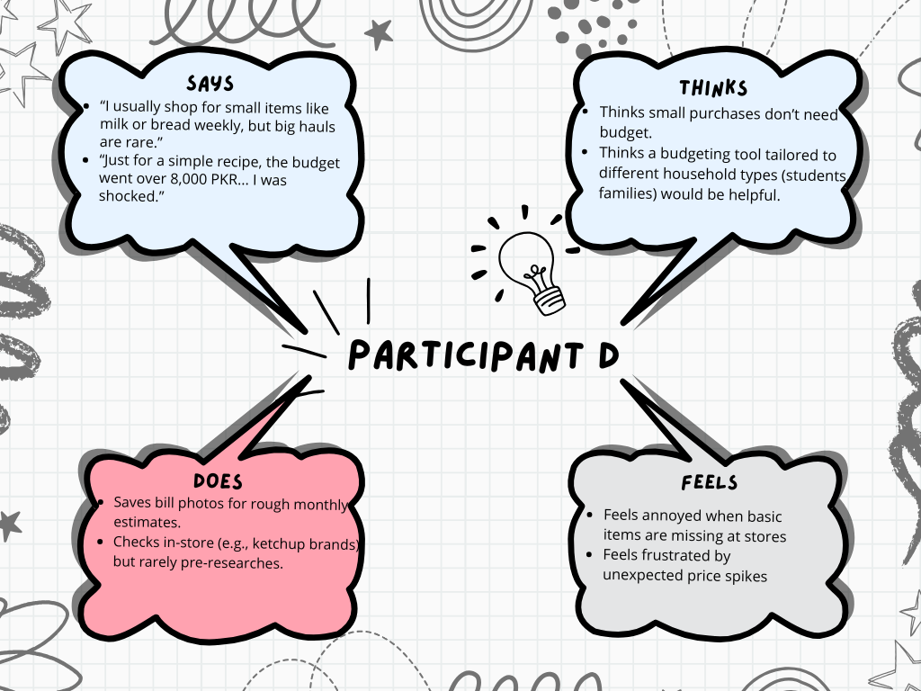

#### **Participant E**

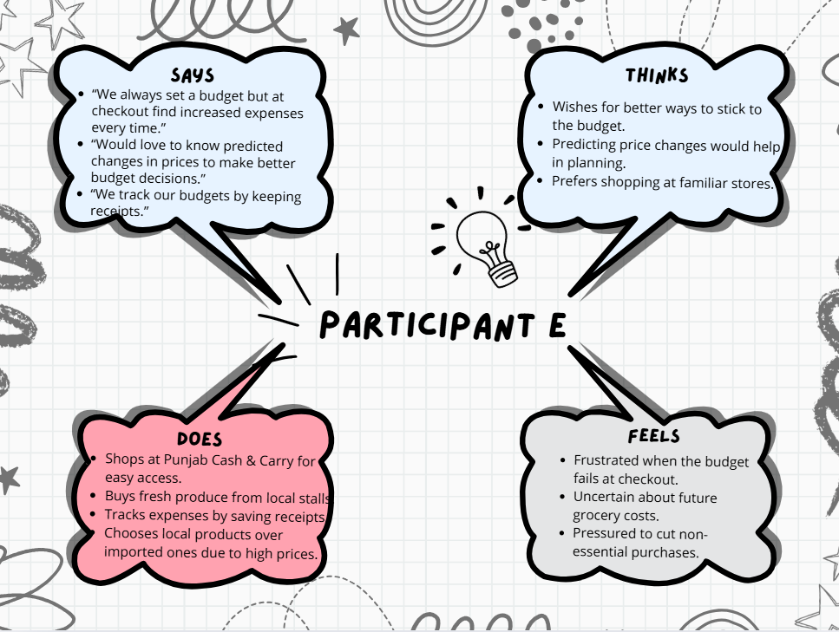

#### **Participant F**

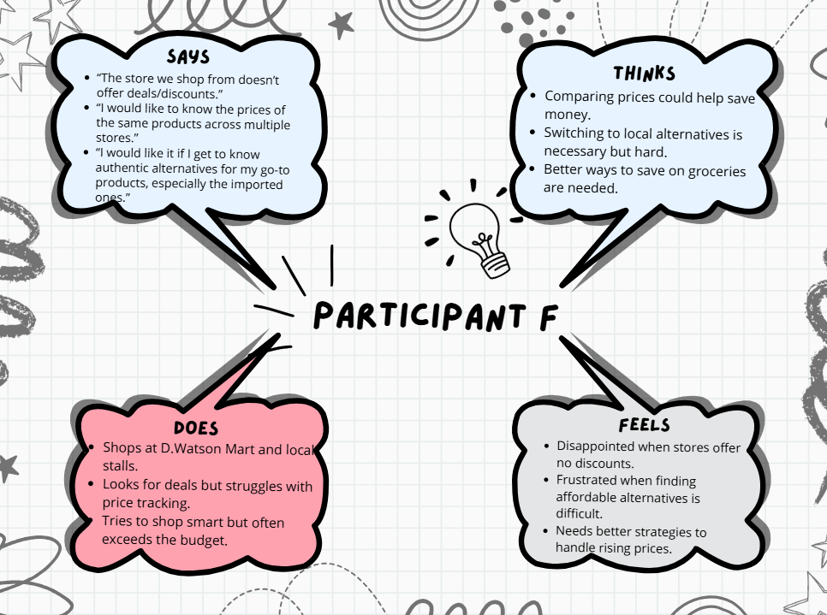

#### **Participant G**

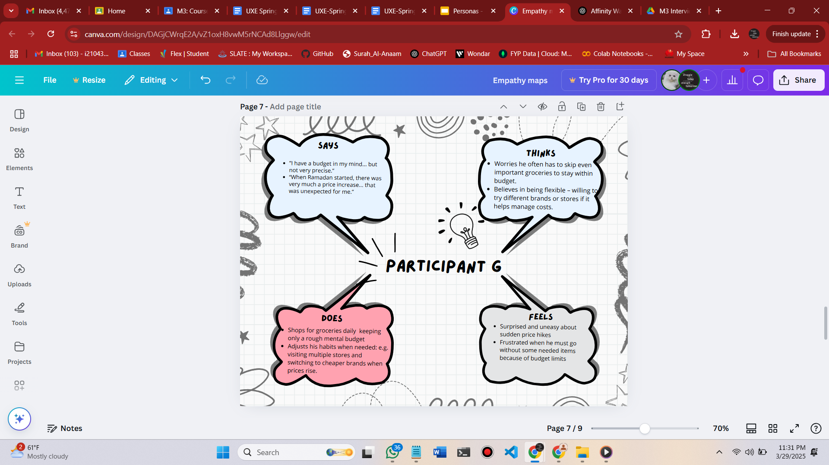

#### **Participant H**

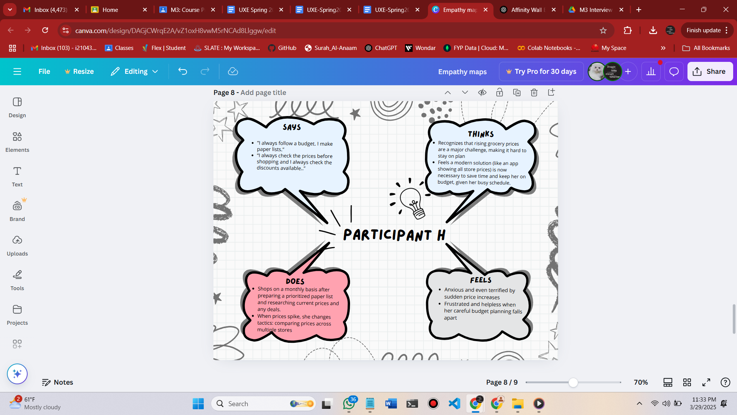

## 2.2 personas

**Persona 1**

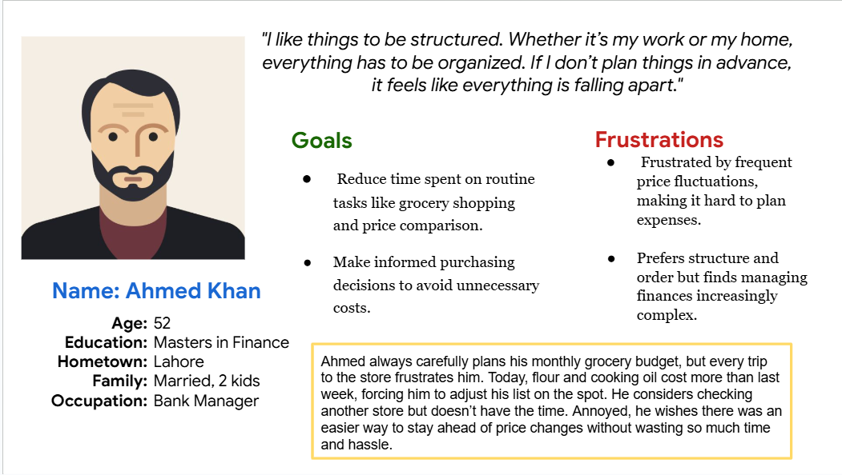

**Persona 2**

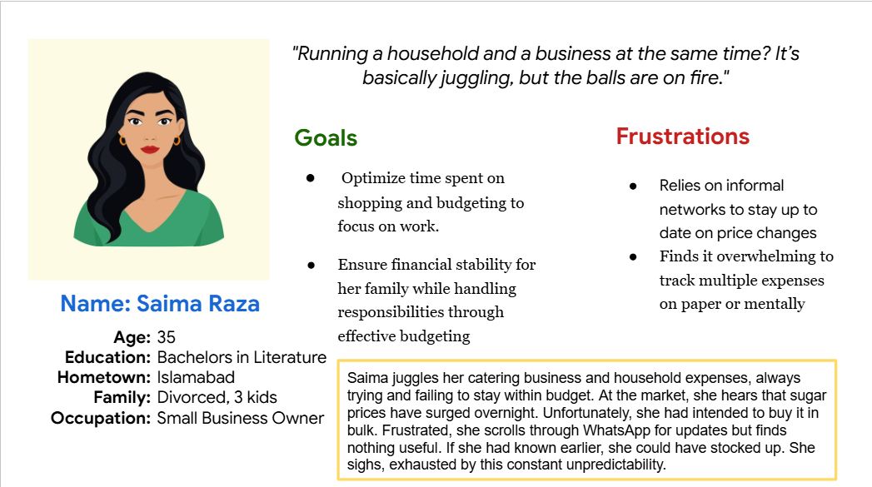

**Persona 3**

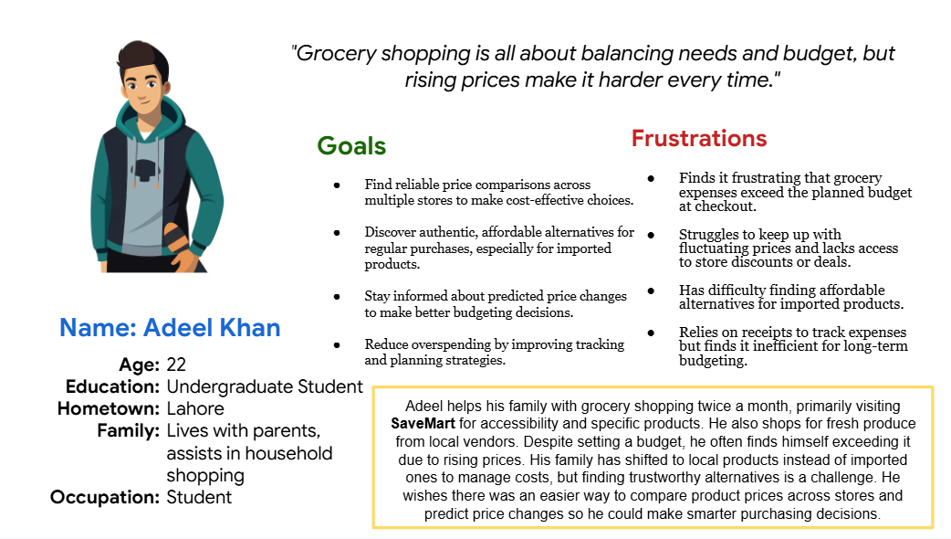

**Persona 4**

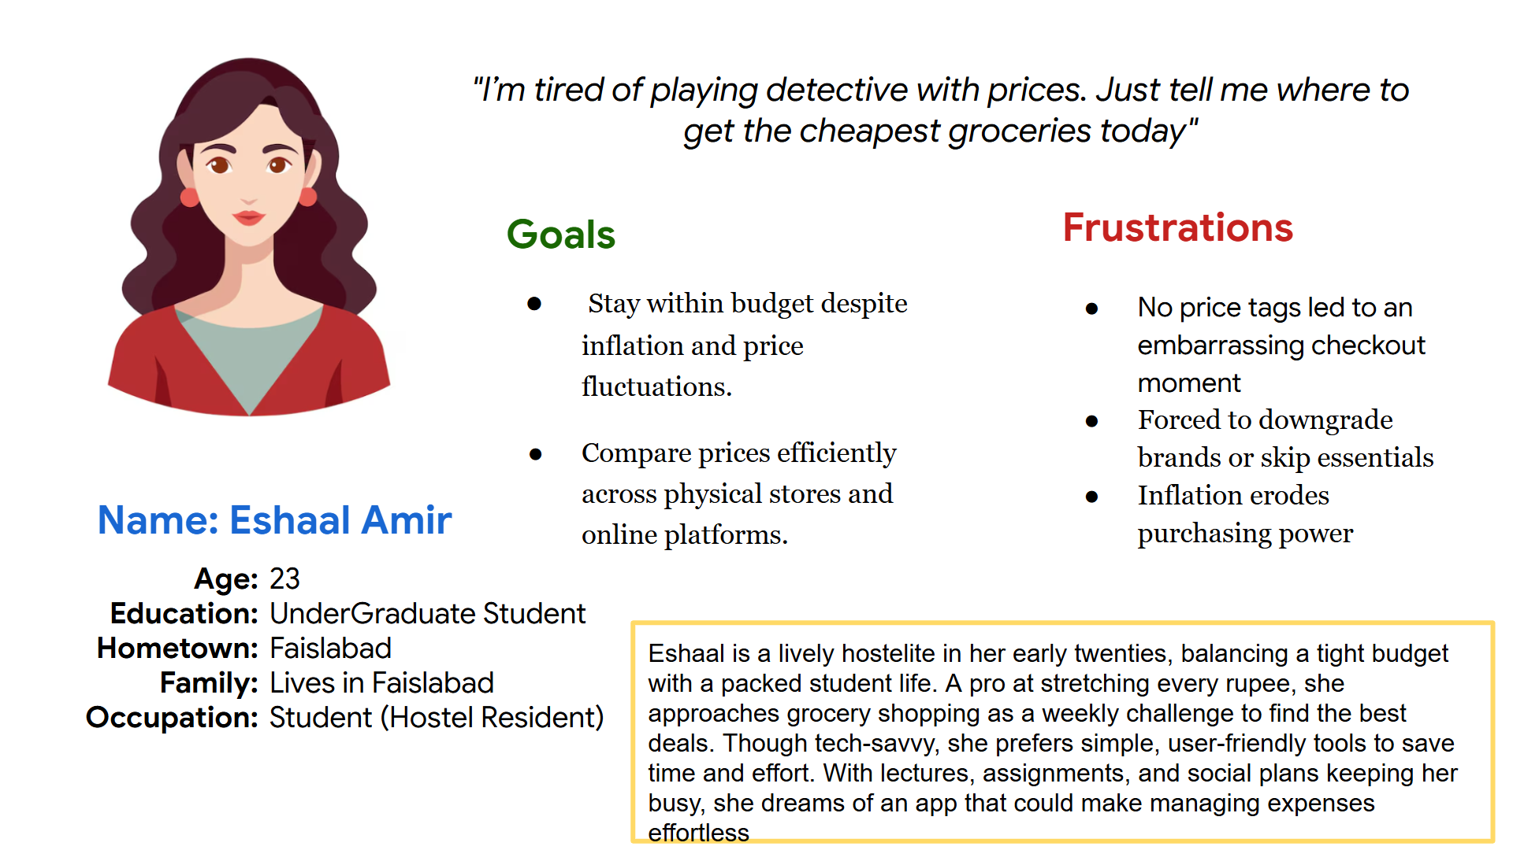

# Wireframes

Note that we have used a different font to represent pencil-like writing.

## Screenshots

<https://www.figma.com/design/CdBOo0mBZToy0HDkvtGwjM/PriceGuard-WireFrames?node-id=0-1&p=f&t=pHBamatC50iCGma3-0>

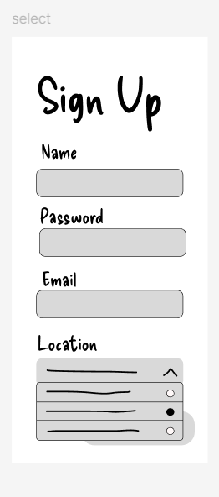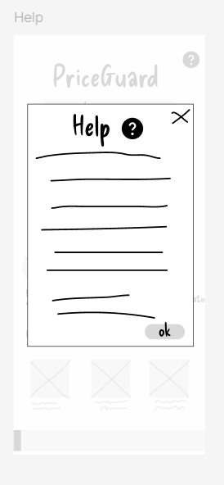

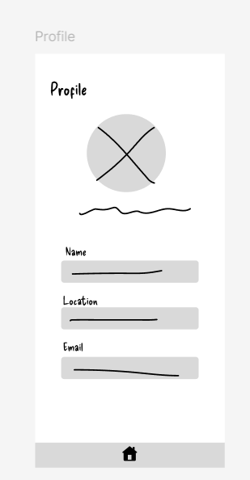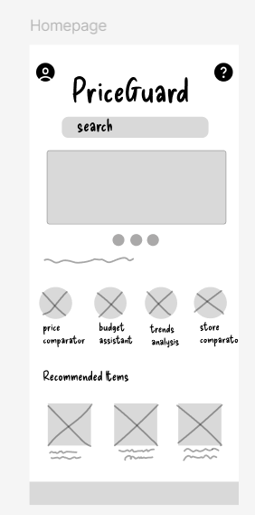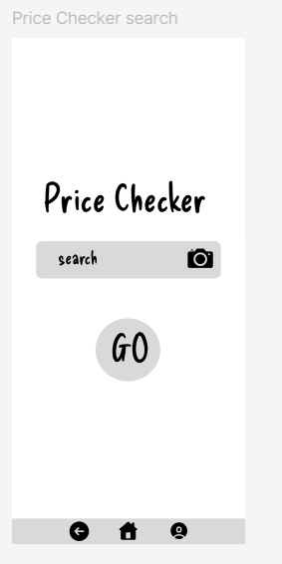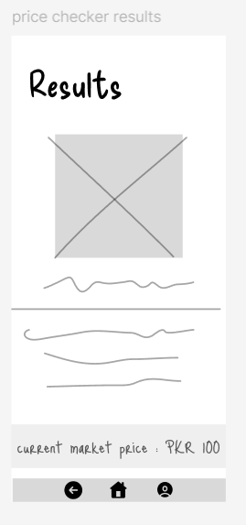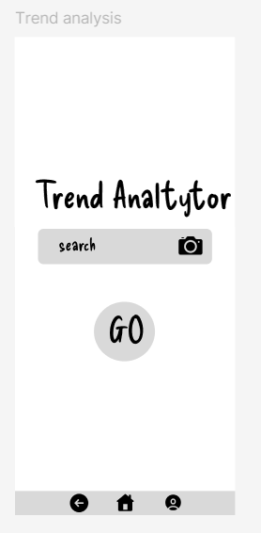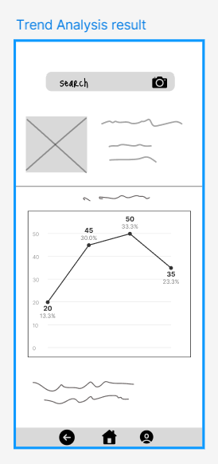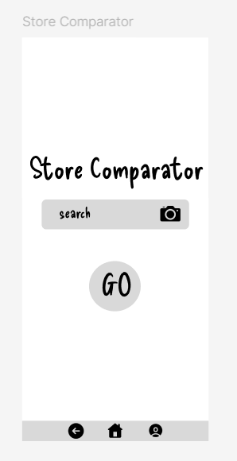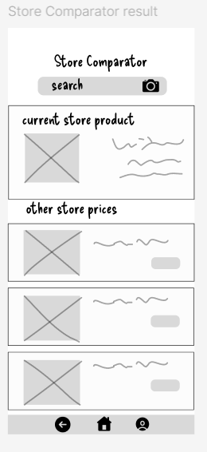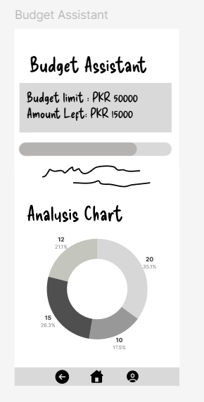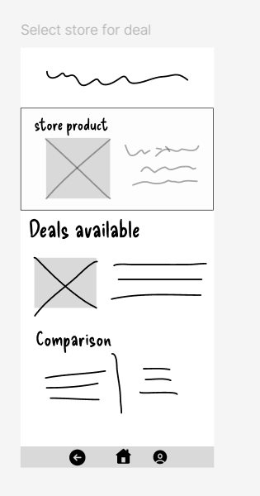

## 

## Navigation Flow

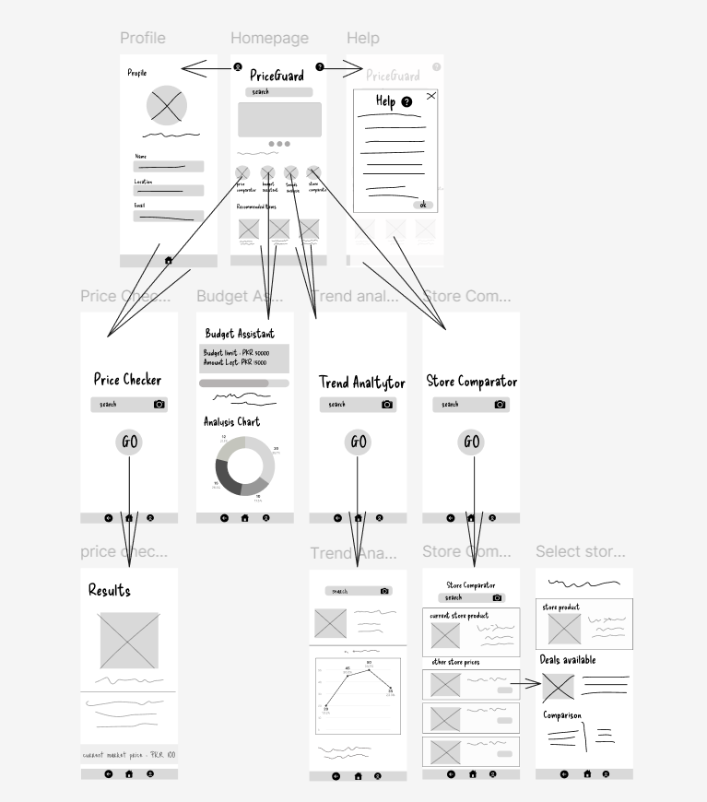

# Lo-fi Prototype

<https://www.figma.com/design/uGPH489B4qEcjBMLTnH8Qq/lo-fi_PriceGuard?node-id=0-1&p=f&t=FKYei1ILKmrh9gmv-0>

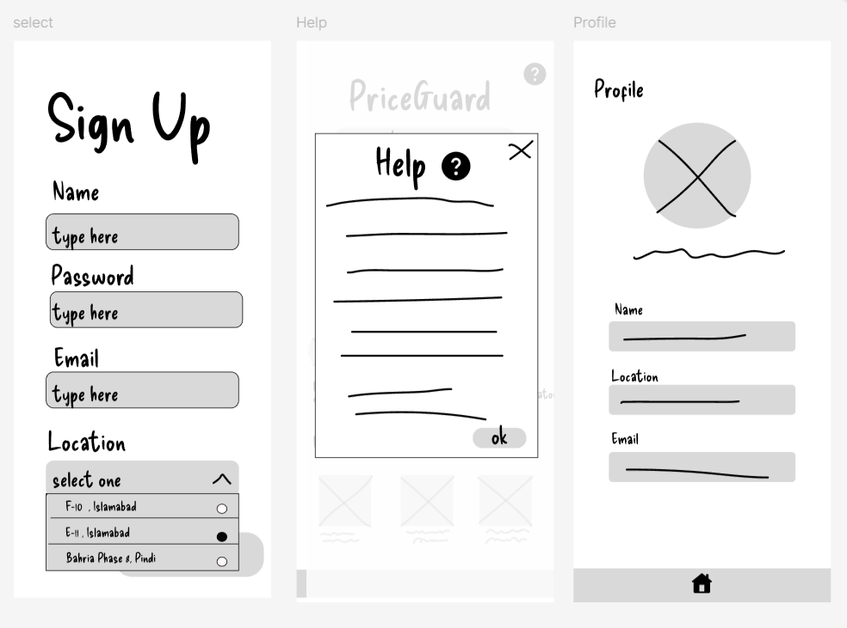

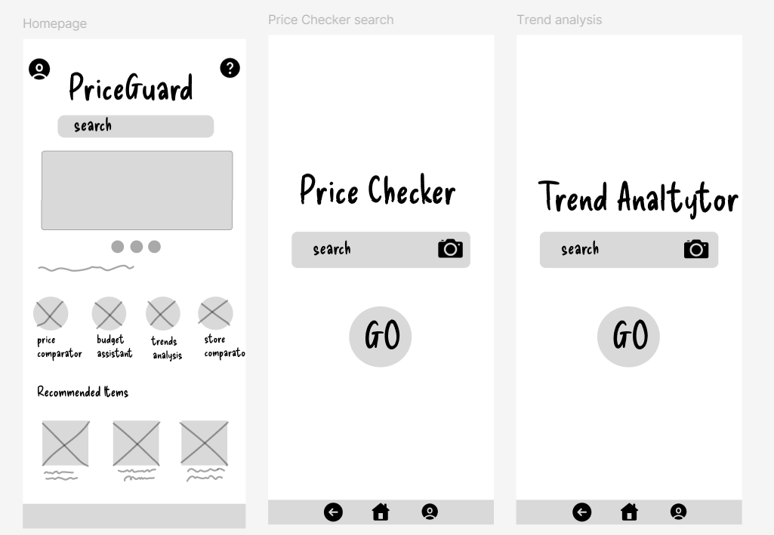

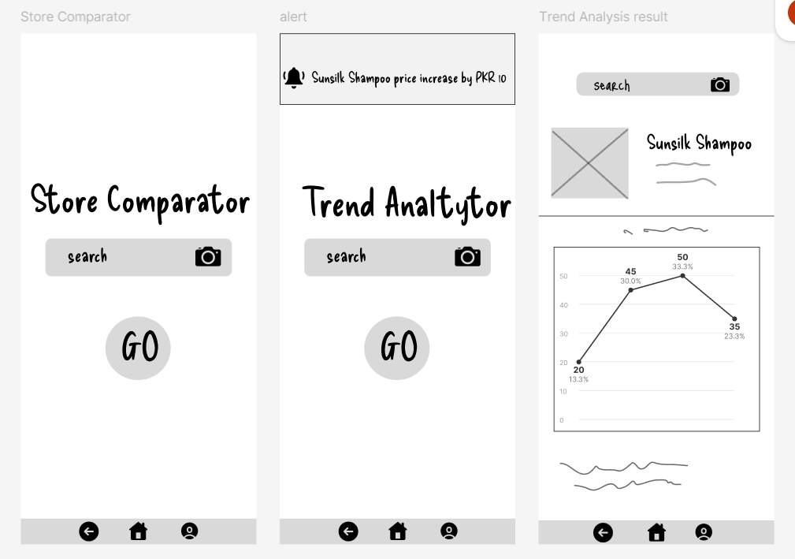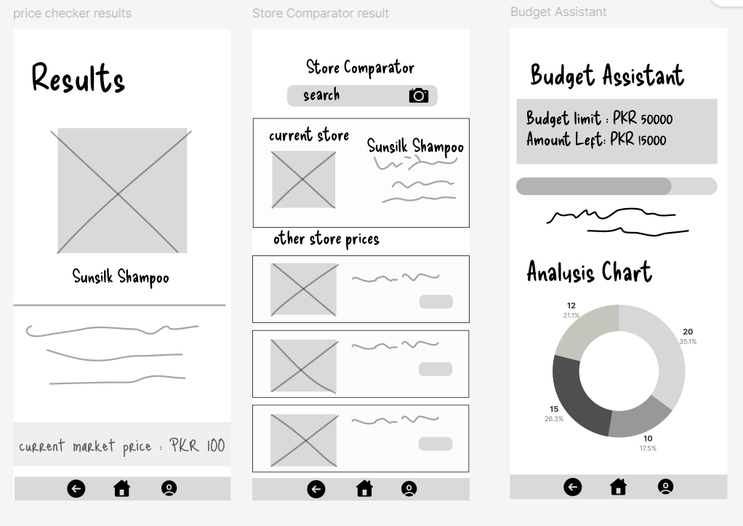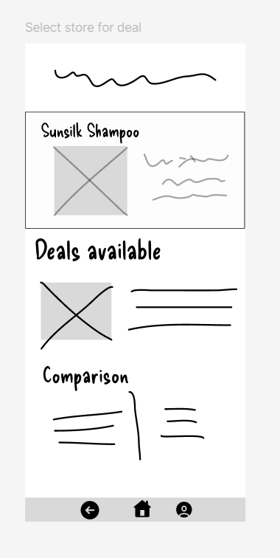

# Mid-Fi Prototype

## Link to Medfi Demo Video : [medfi_demo.mp4](https://drive.google.com/file/d/1Ga8C-3BCqAcy6xJbJIecTogF6j0bqLfl/view?usp=sharing)

## Mid-Fi Screenshots

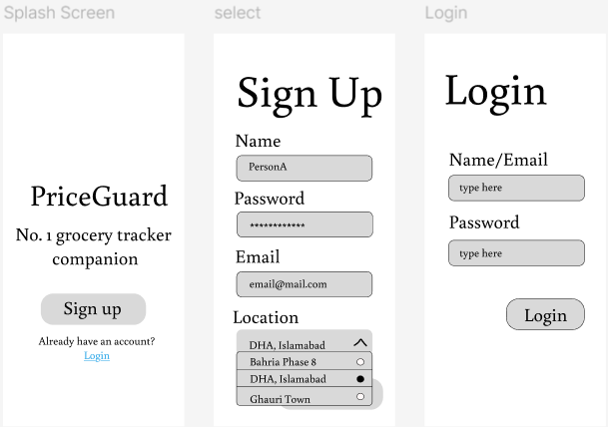

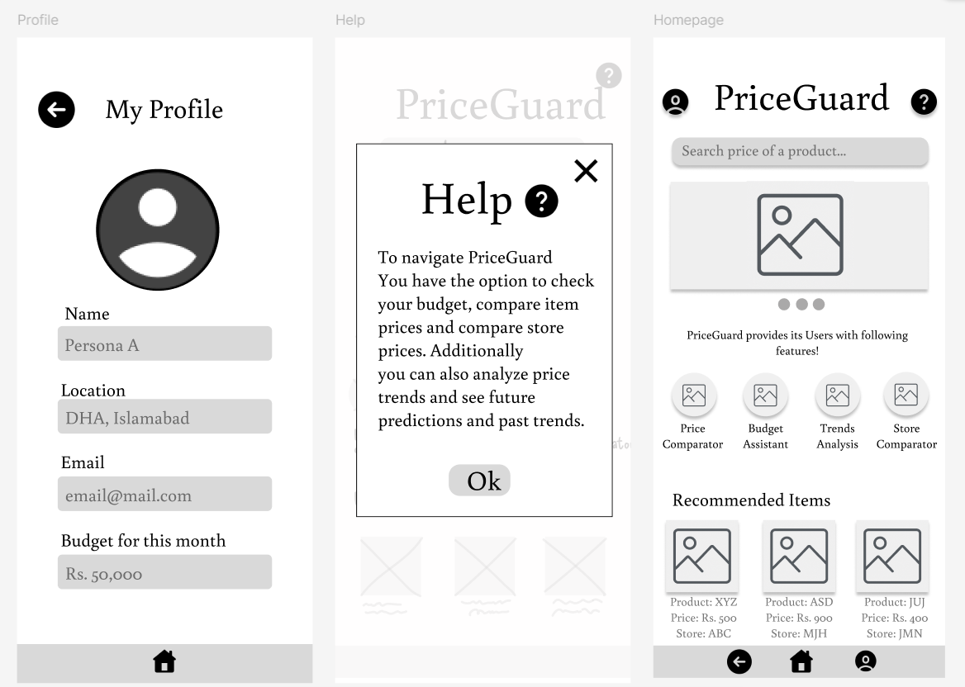

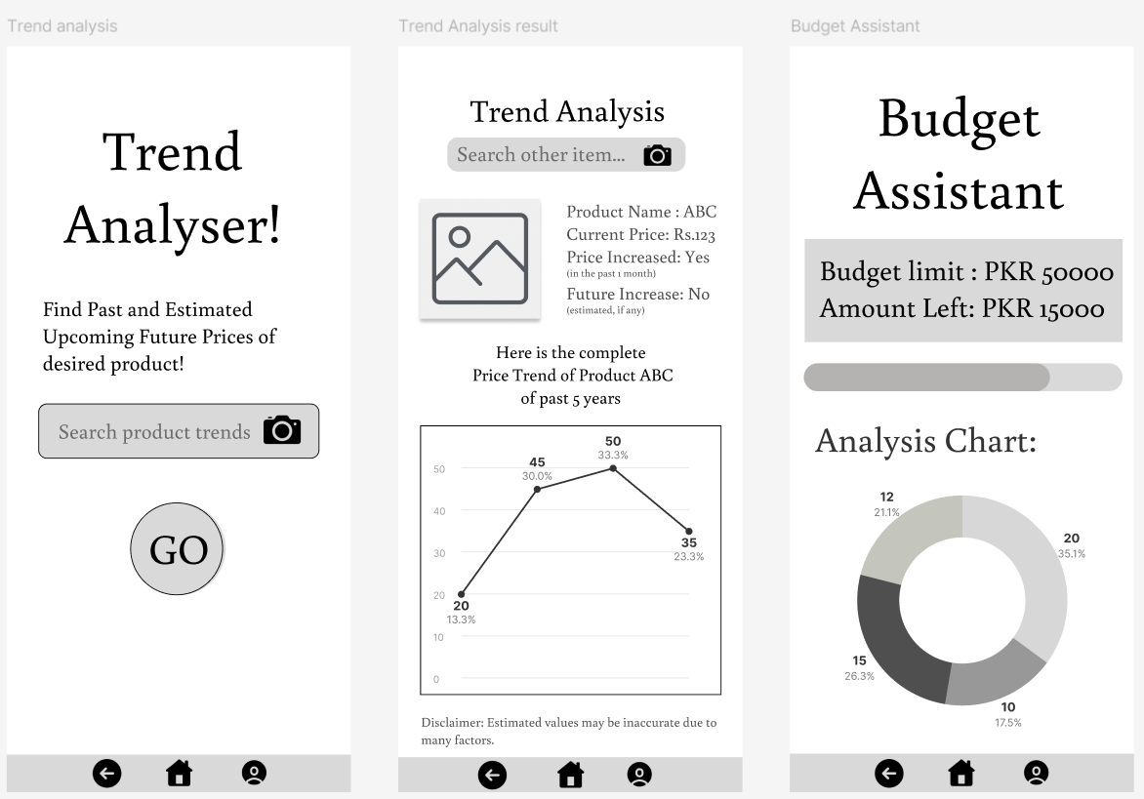

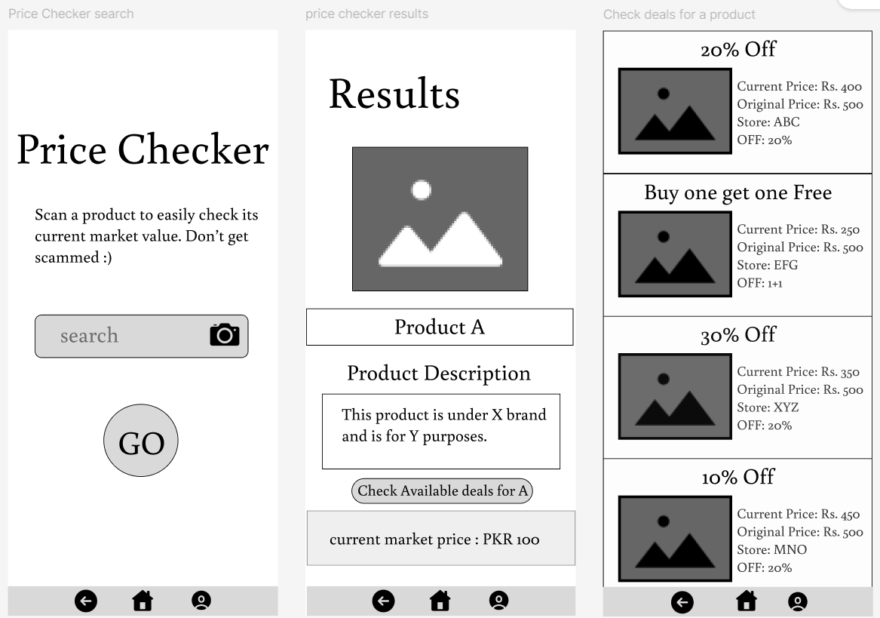

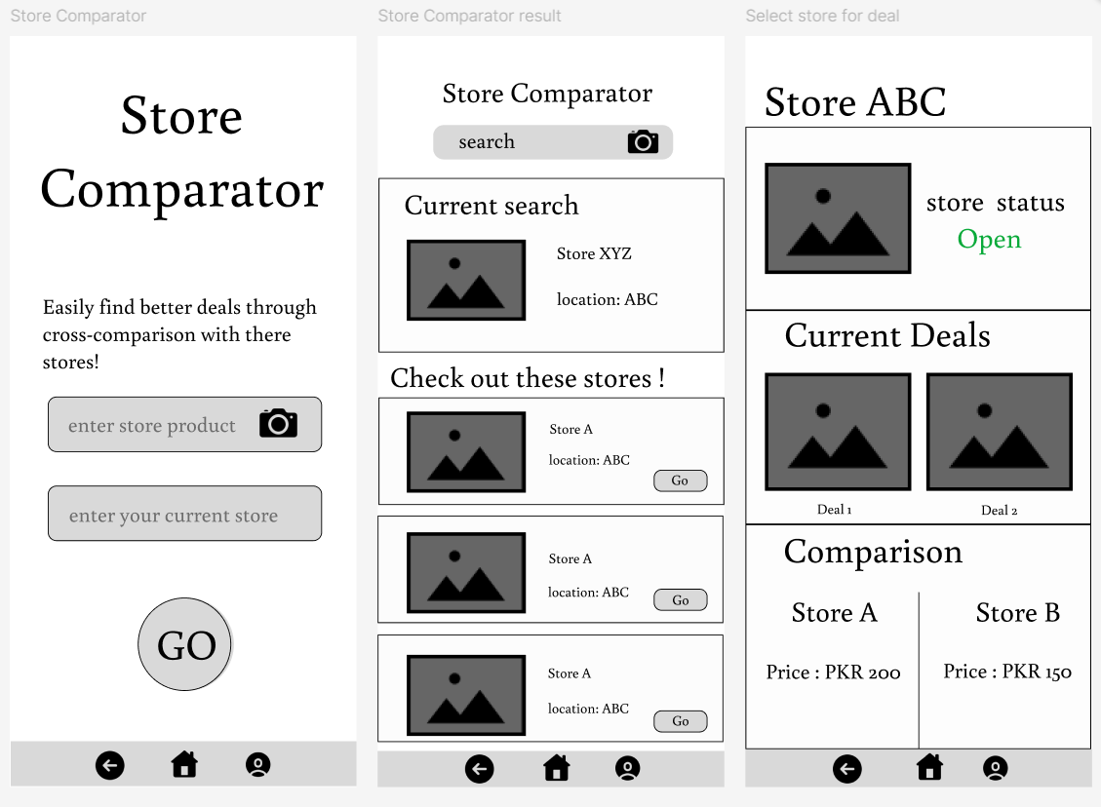

## User Test LogSheet Results: [Logging Sheet](https://docs.google.com/spreadsheets/d/1OvZdadd42M1IHdbFdHghdoOZ2yvKlPEwKuiGG80zTcs/edit?gid=0#gid=0)

## Figma link to Mid-Fi

https://www.figma.com/design/etCBVKyuOehKF36Q9UPVCG/PriceGuard-Med-Fi?node-id=0-1&p=f&t=jy5hgrQkvbJmJNUH-0

# Heuristic Evaluation

## Visibility of System Status

Finding: There is no way to let the user know action is in progress. Otherwise buttons do animate to let the users know that they have successfully placed a request for an action (for example: pressing a button)

Severity: 2

Recommendation : Add a loading bar or spinner to let users know their action is in progress in case of slow response time.

## Match between the System and real World

Findings: Consistently familiar icons and terms are used for the ease of users. No user felt difficulty in understanding the purpose of various buttons and icons.

Severity: 0

Recommendation: None

## User Control and Freedom

Findings: Users can easily go back from any action they’ve done. There is a back button on every page including Login and SignUp. During testing users experienced no friction. However, profile details cannot be edited.

Severity: 1

Recommendation: Add an edit button

## Consistency and Standards

Findings: All pages use consistent wording, icons and icon placement. For example the search pages for Trend Analytor, Price Finder and Store Comparator, all use the same CTA which is the “GO” Button. No user assessed any difficulty here.

Severity: 0

Recommendation: None

## Error Prevention

Findings: No error message in the scenario a weak password is entered during Signup. SignUp could use refinement.

Severity: 1

Recommendation: Add a way to check if the user entered a weak password

## Recognition rather than Recall

Findings: All images are labelled and any icons used are widely used worldwide. Users faced no issues in this area.

Severity: 0

Recommendation: None

## Flexibility and Efficiency in Use

Findings: There are no shortcuts for more seasoned users to do their tasks more efficiently.

Severity: 1

Recommendation: Add a functionality that allows users to easily check both current price of a product and compare stores simultaneously for faster use.

## Aesthetic and Minimalist Design

Findings: Design is minimal and neat. Users appreciated the ease of flow and lack of screen clutter. The screens are to the point.

Severity: 0

Recommendation: None

## Help Users Recognize, Diagnose and Recover from Errors

Findings: No error message in the scenario a wrong password is entered during Login. Login could use refinement.

Severity: 3

Recommendation: Add a way to check if the user entered a wrong password

## Help and Documentation

Findings: Help page is provided on the homepage once a user signs up. However it is brief and could be more detailed

Severity: 1

Recommendation: Add a visual walkthrough to aid users more easily on what each functionality within the app does.

# Design Principles : Gestalts Principles

We kept the following principles in mind when designing our prototype.

## Similarity

The goal was to keep similar CTAs looking the same so that users could easily perceive they have the same function. Keeping the design consistent so that users would not get confused. We did this by standardizing the Sign Up/ Login Buttons, the GO CTAs and the navigation bar at the bottom of the screen.

## Proximity

We kept similar items closer together for example, the store results, the two search bars on Store comparator to indicate both can be used to search for a specific product in a specific store. In the Profile section, we kept the user details grouped together.

## Common Region

Our aim was to keep similar items grouped together for ease of use for the user. For example, in the homepage, the services (Trend Analytor, Price Checker and Store Comparator) were all grouped together. Similarly, the recommended products are also in a separate group.

The same way, we applied this principle in the store comparator, keeping the searched store and store results separate, creating a visual hierarchy and grouping the similar items i.e results.

# Hi-Fi Prototype

## Hi-Fi Screenshots

## 

## 

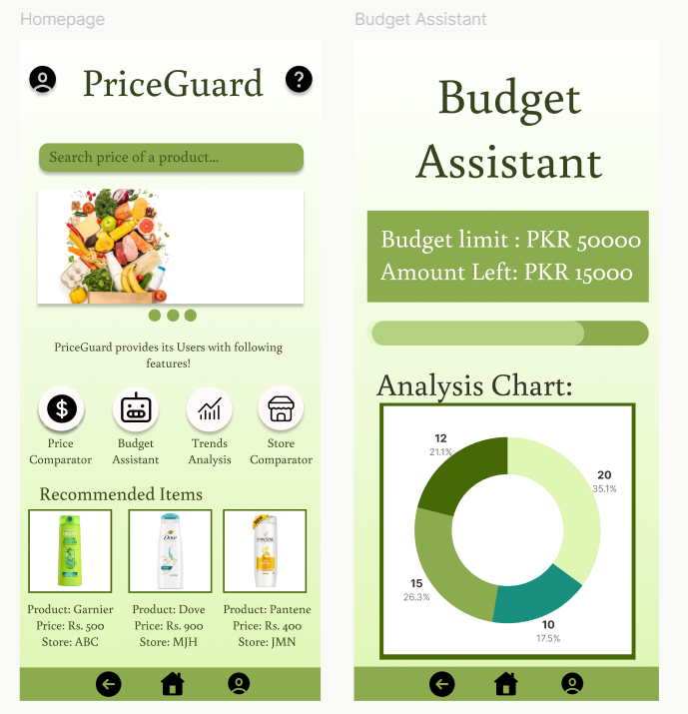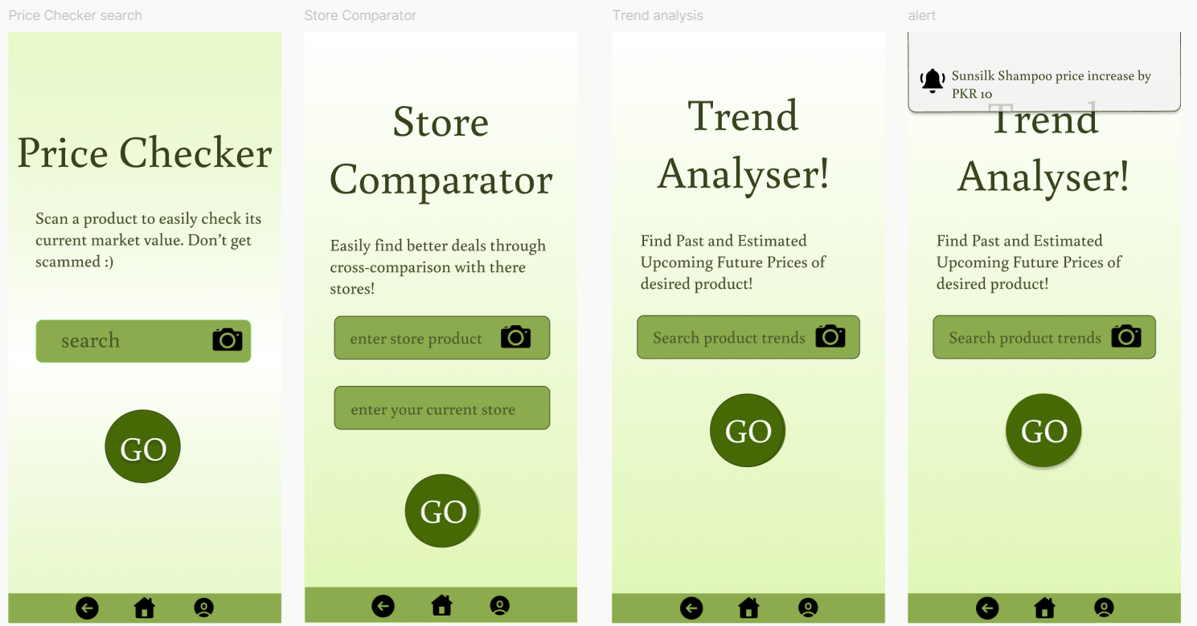

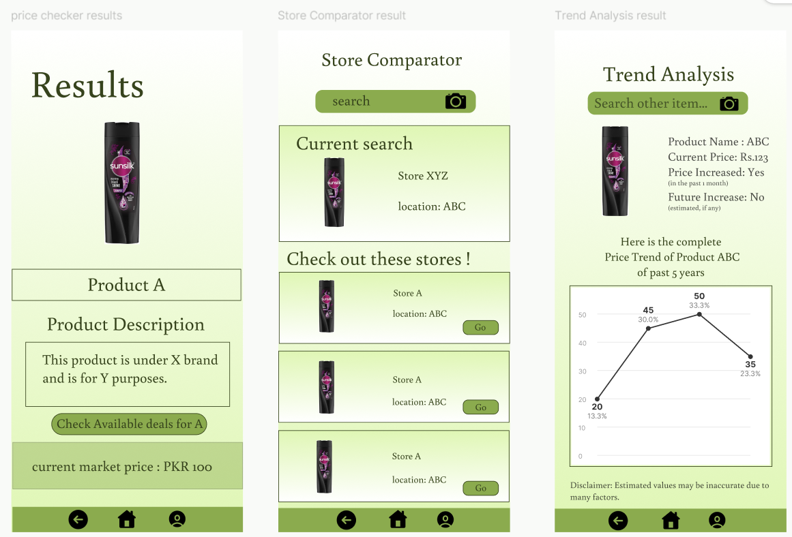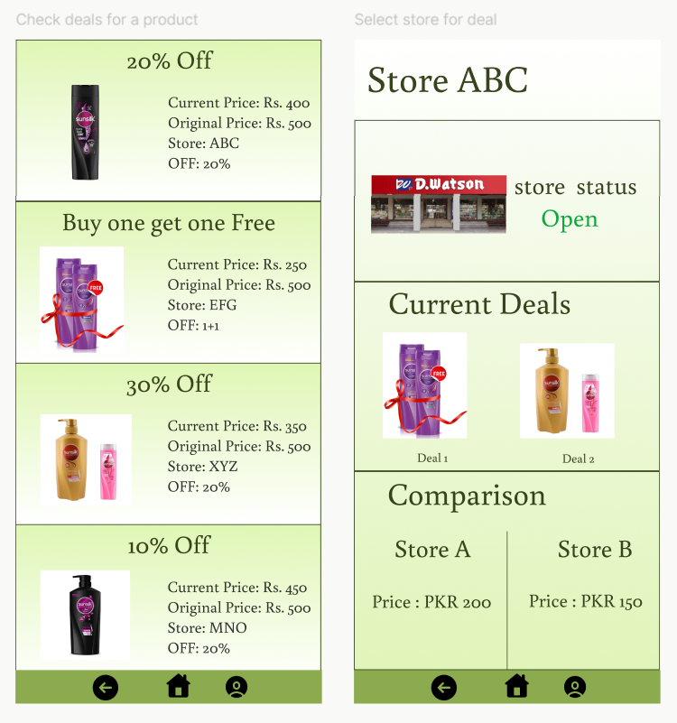

## Figma link to Hi-Fi

<https://www.figma.com/design/hLR5mK6qE8V3QpgxehtCHU/Untitled?node-id=0-1&t=9hCAisi7WJ0gbZ5j-1>

## 

## Video Link to Hi-Fi

[Screen Recording 2025-05-04 235035.mp4](https://drive.google.com/file/d/1zyqAOzibXuqVulDGxzrLgzwlqOk_XUVq/view?usp=sharing)

# Conclusion

PriceGuard aims to serve the average man or woman in navigating daily grocery shopping by providing a mobile app that empowers budget-conscious shoppers in Pakistan to manage rising grocery prices (8.5% annually). With features like real-time price tracking, store comparisons, inflation trend analysis, personalized recommendations, predictive price insights, and instantaneous alerts, PriceGuard enables users—whether middle-aged professionals like Participant A, who value structured budgeting, or young students like Participant C, who seek affordable options—to make informed, cost-effective purchasing decisions. Tailored to diverse needs, it supports UN SDG 2 (food security) and 12 (responsible consumption) by promoting accessible, sustainable shopping practices.

Through the development process, we learned that PriceGuard’s strength lies in its all-in-one approach, distinguishing it from direct competitors like Inflatacart, Grocery Tracker, and Price Book, which lack real-time updates or personalization, and indirect competitors like Flipp and Instacart, which focus narrowly on deals or delivery. The competitive audit highlighted opportunities to leverage credible data, intuitive UX, and broad comparisons while addressing gaps in automation and accessibility. The user testing plan, refined through participant insights and iterative feedback confirmed PriceGuard’s usability for both tech-savvy and less tech-savvy users, ensuring relevance in Pakistan’s economic context. These processes underscored the importance of balancing robust functionality with simplicity to meet the diverse needs of middle-aged planners, time-constrained mothers, and budget-conscious youth. By continuing to refine its features and usability, PriceGuard is poised to become a vital tool for Pakistani shoppers combating inflation and optimizing their grocery budgets.

# Appendix

## Project Brief

The **PriceGuard** app is a shopping assistant designed to help users track grocery prices, compare store deals, analyze price trends, assist with budgeting, and provide personalized shopping recommendations. The app aims to support budget-conscious shoppers, helping them save money and make informed shopping decisions by providing real-time price comparisons and alerts.

### **Changes to the Project Brief**

There have been **no changes** to the scope or plans of the project. The project has proceeded according to the initial plan, with a focus on:

* **Creating mid & high-fidelity prototypes** based on user needs.
* **Testing the app’s usability** through various scenarios, focusing on core features such as price comparison, budgeting, and price alerts.